**CMS Configurator User Manual**

*V0.1.0-rc1*

1. User Interface General

Main Project Icons

New Project/Open/Save/Config Error

Configuration menu

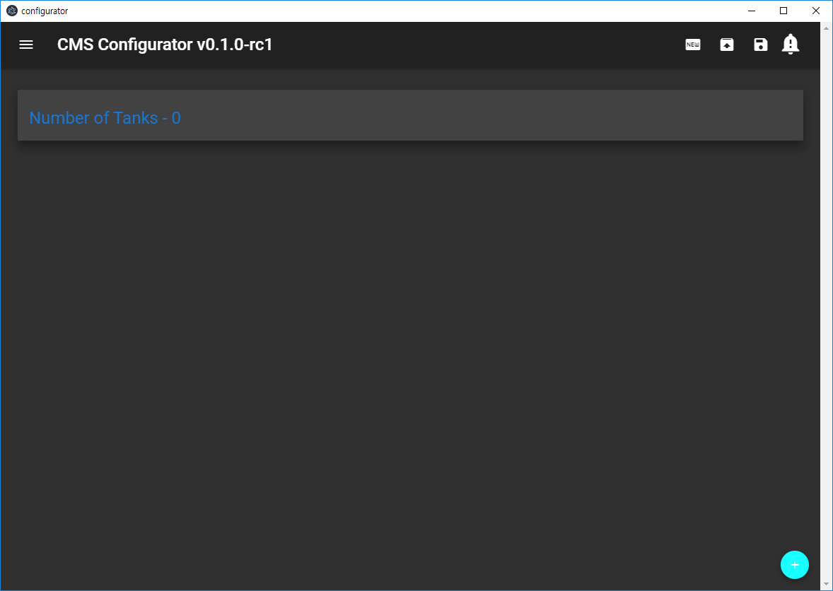

1. Configuration Menu

IO Configuration

Tank configuration

Channel List

Alarm List

Config Error List

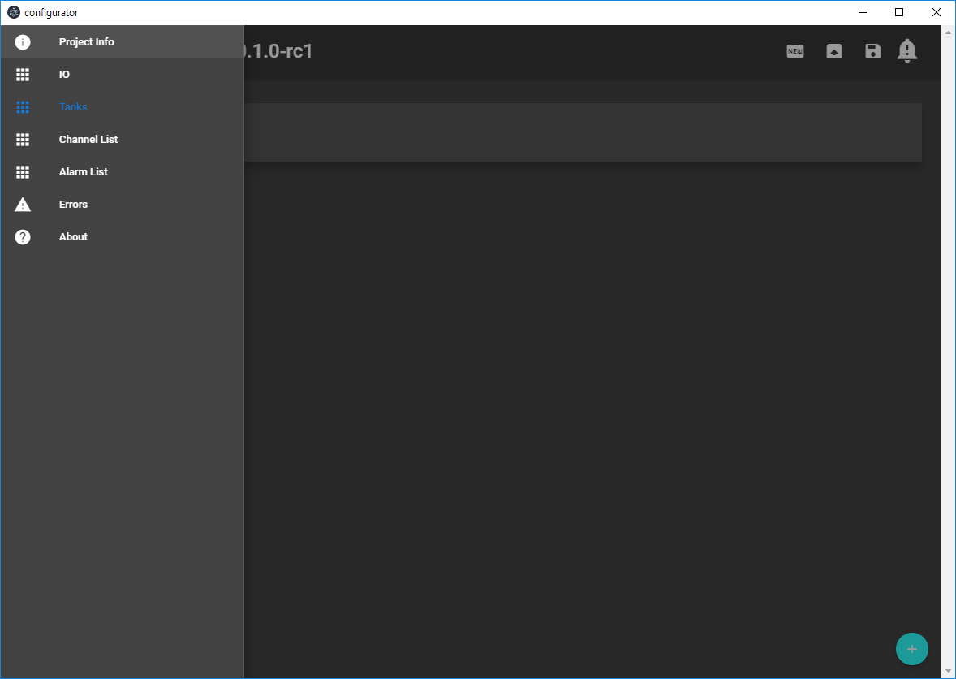

1. IO Configuration

Serial Port Basic setup

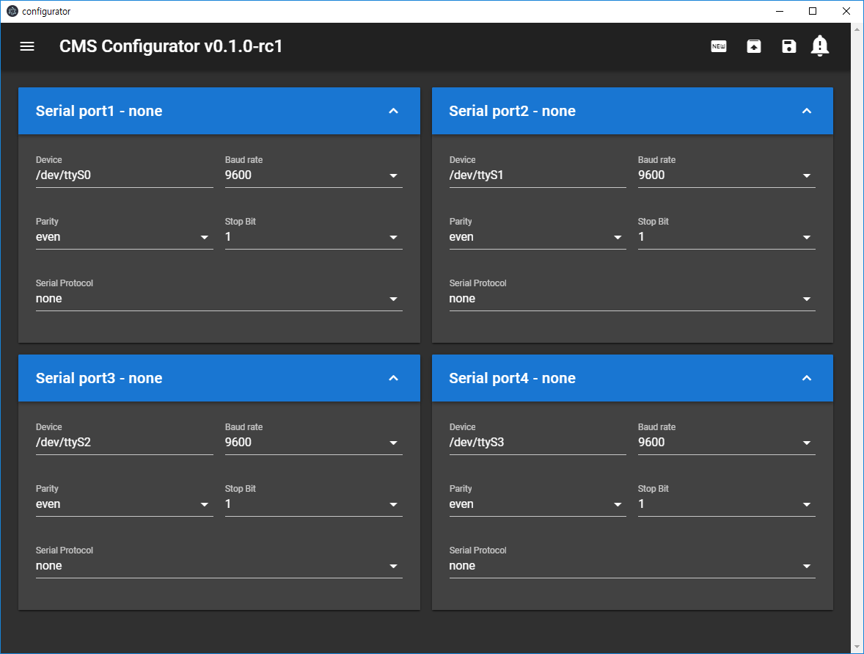

Serial Port Protocol Setup

Currently only Modbus Master/Modbus Slave

1. IO Configuration Modbus Master

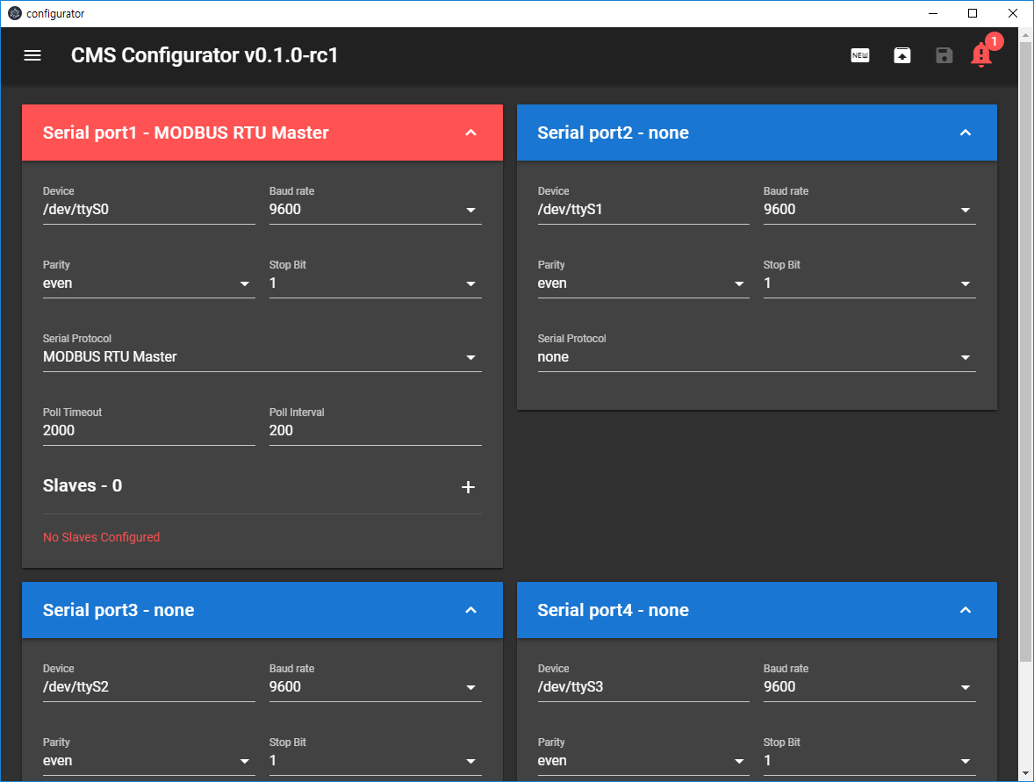

Add Modbus slave

Basic Modbus Master setup

1. IO Configuration Modbus Master – Add Slave

Modbus slave address

Board type (ZB-ANA, ZB-HART)

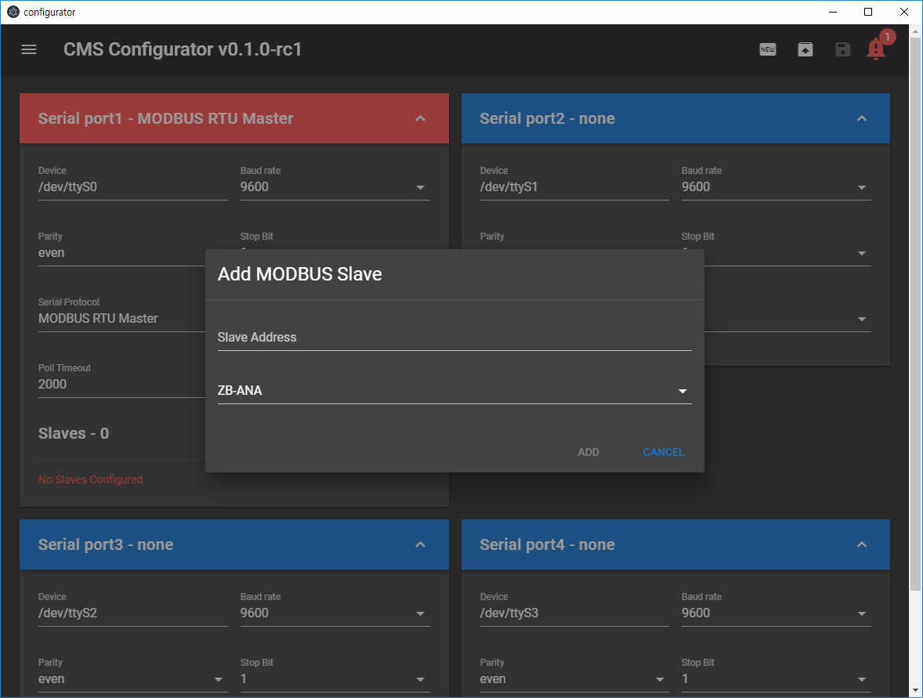

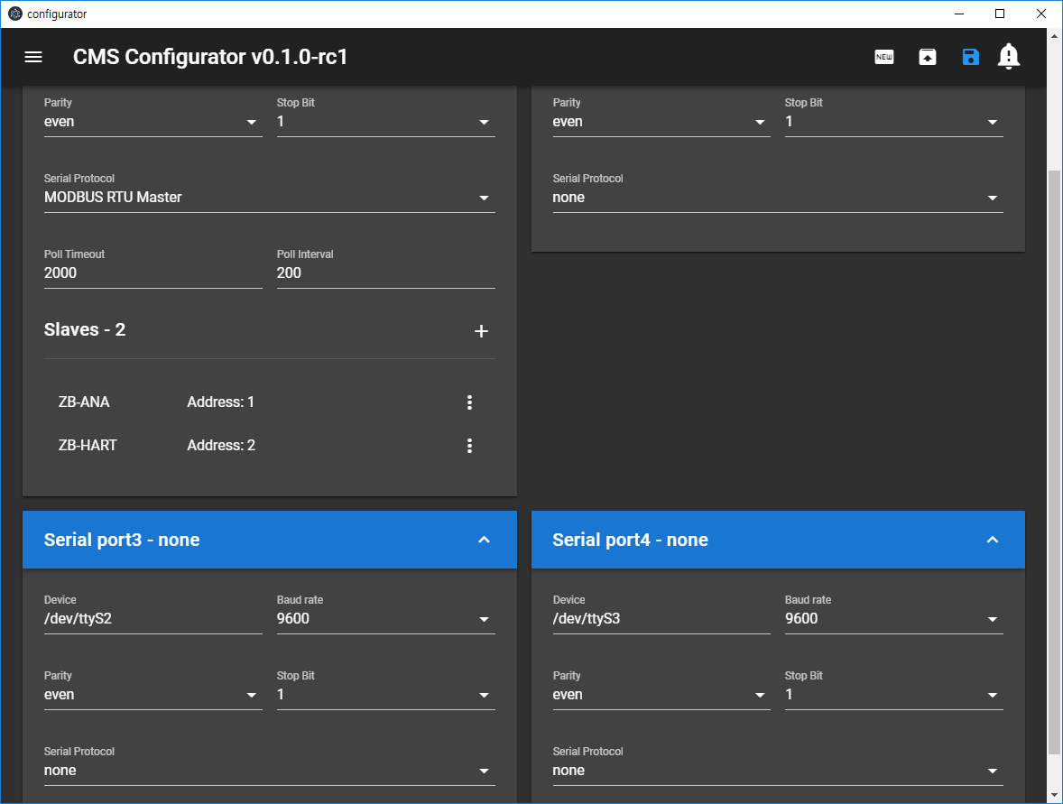

Slave list

@click = slave popup dialog

‘:’ : slave menu options

vcdfcds

Slave address change

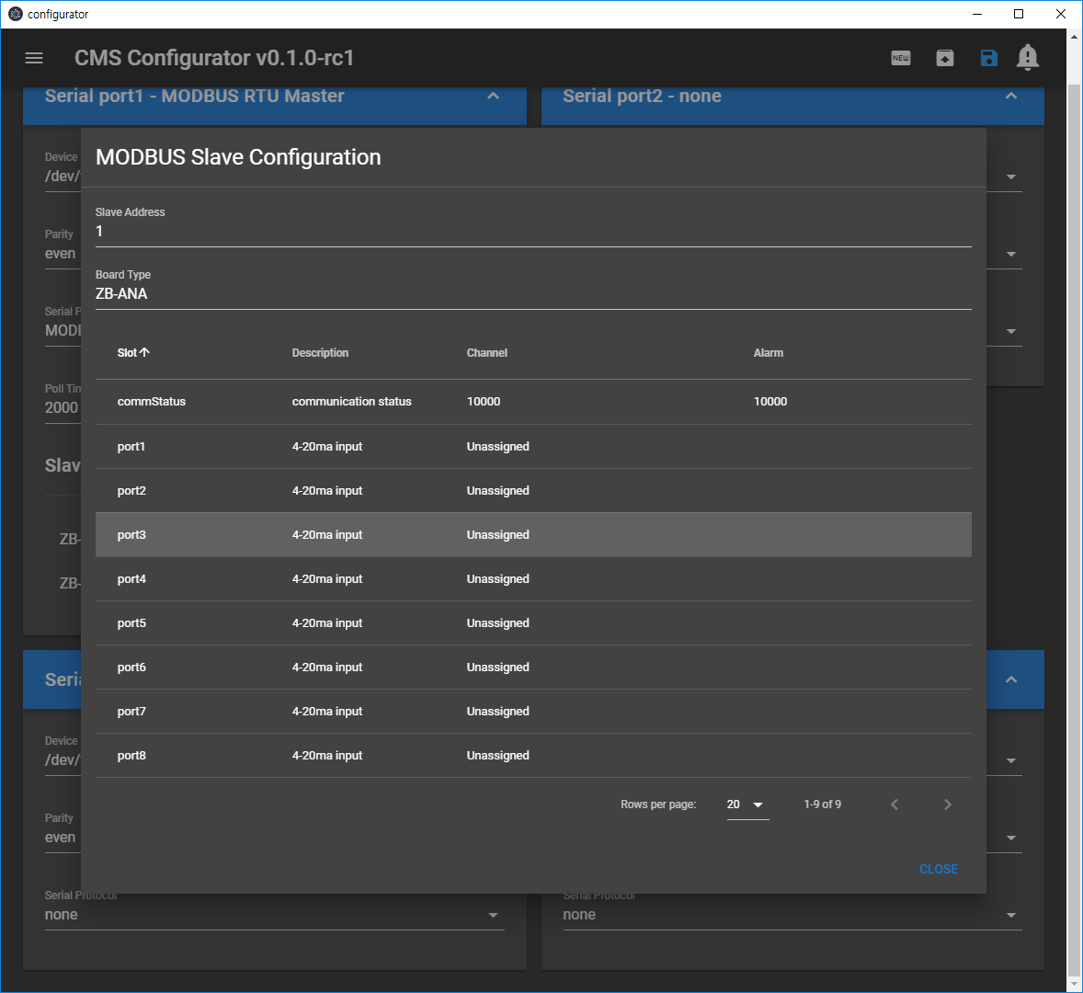

Ports and port assignment status

1. Tank configuration - main

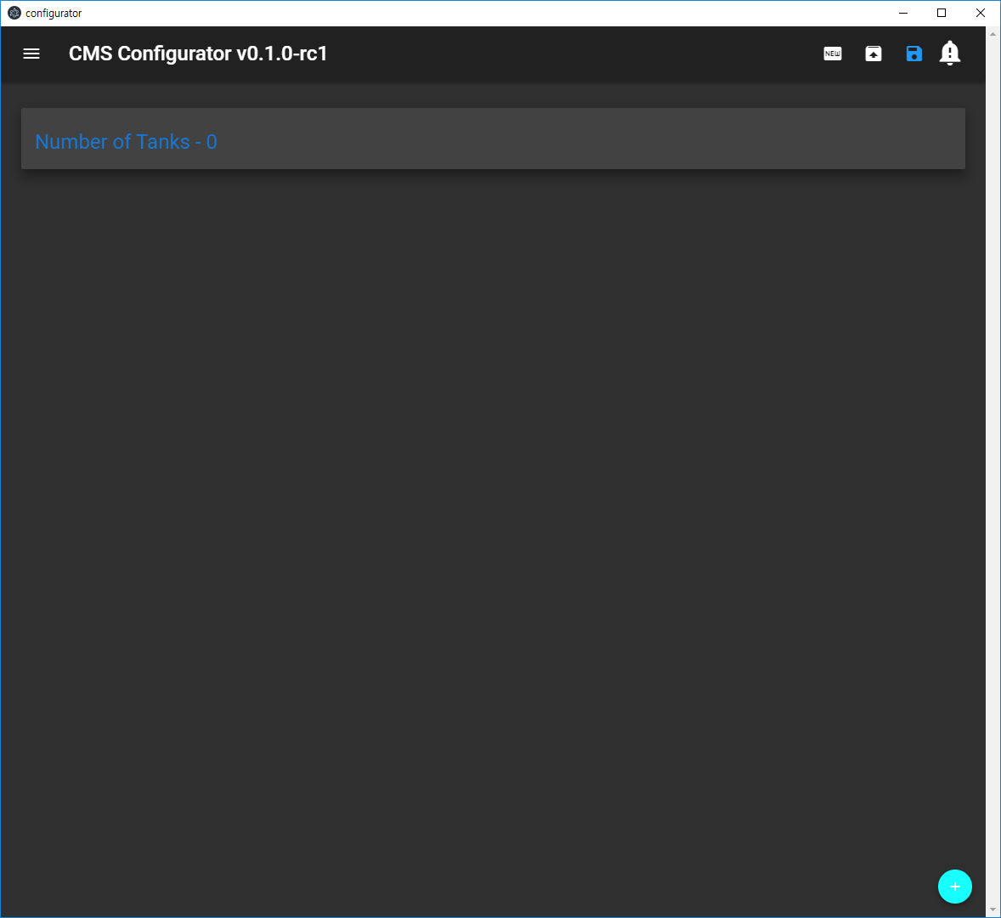

Add new tank

Number of tanks currently configured

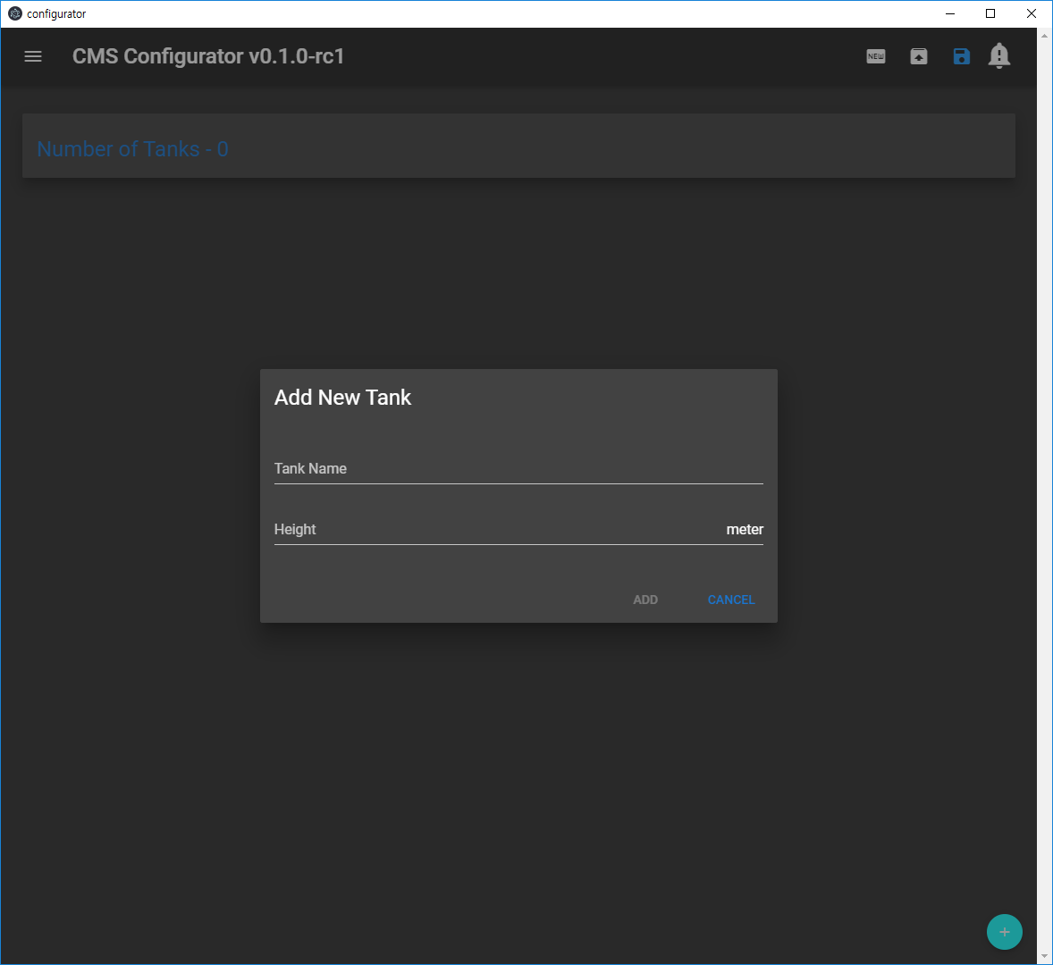

Height

Tank name

1. Tank configuration – level

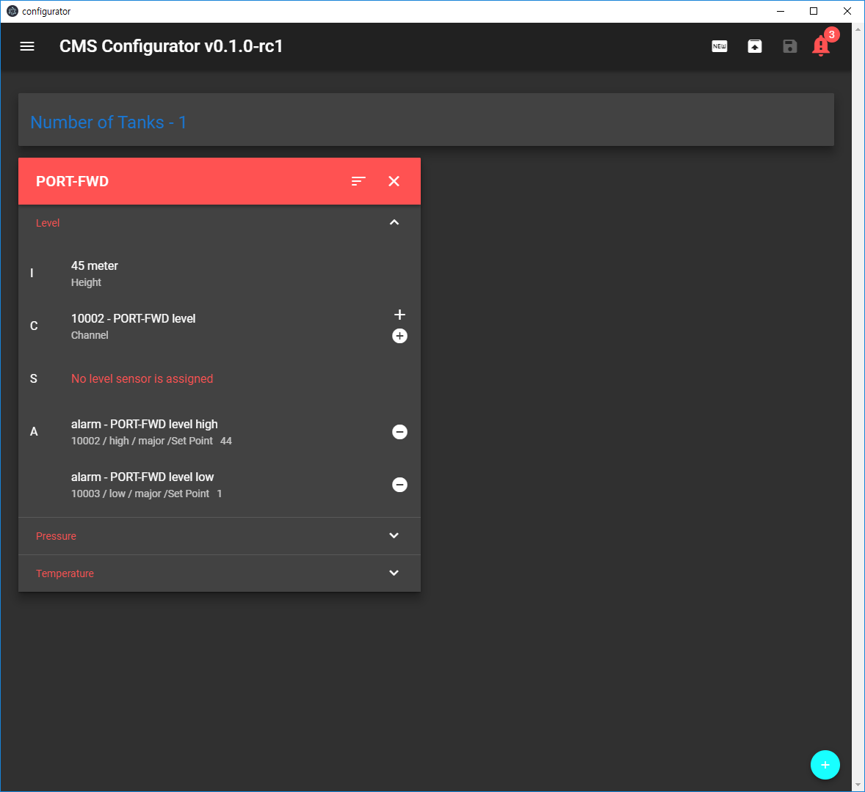

@click = alarm config popup

Delete level alarm

Tank level alarms

Add level alarm

Add level sensor

Basic tank and channel info

1. Tank configuration – add level sensor

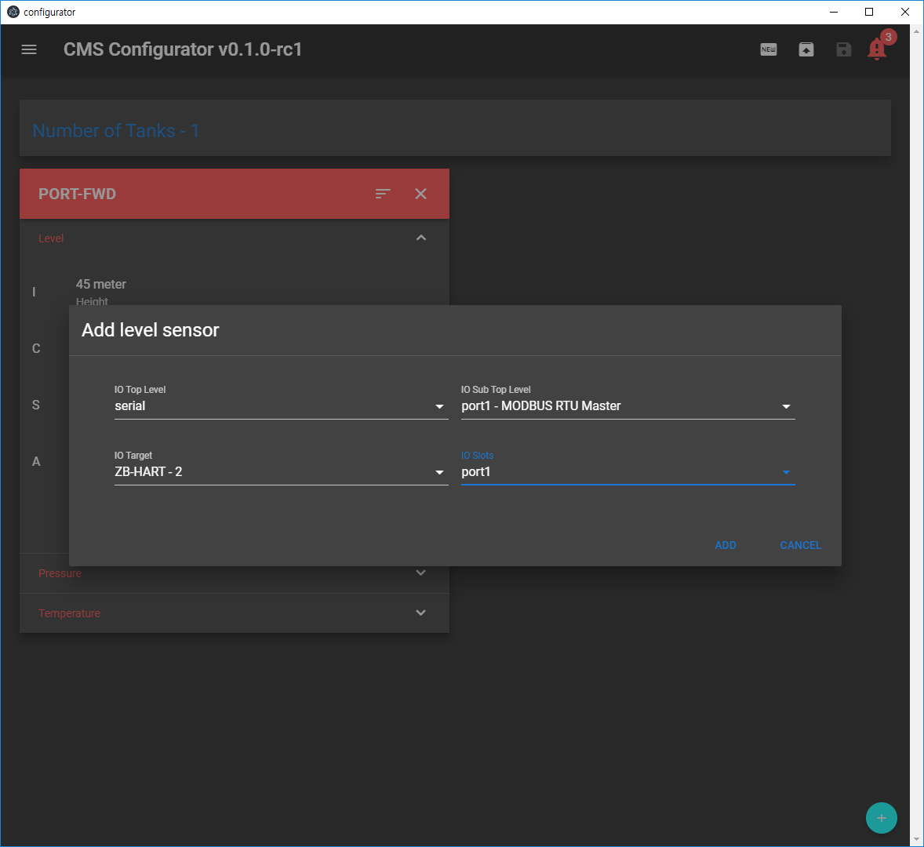

Select board and port

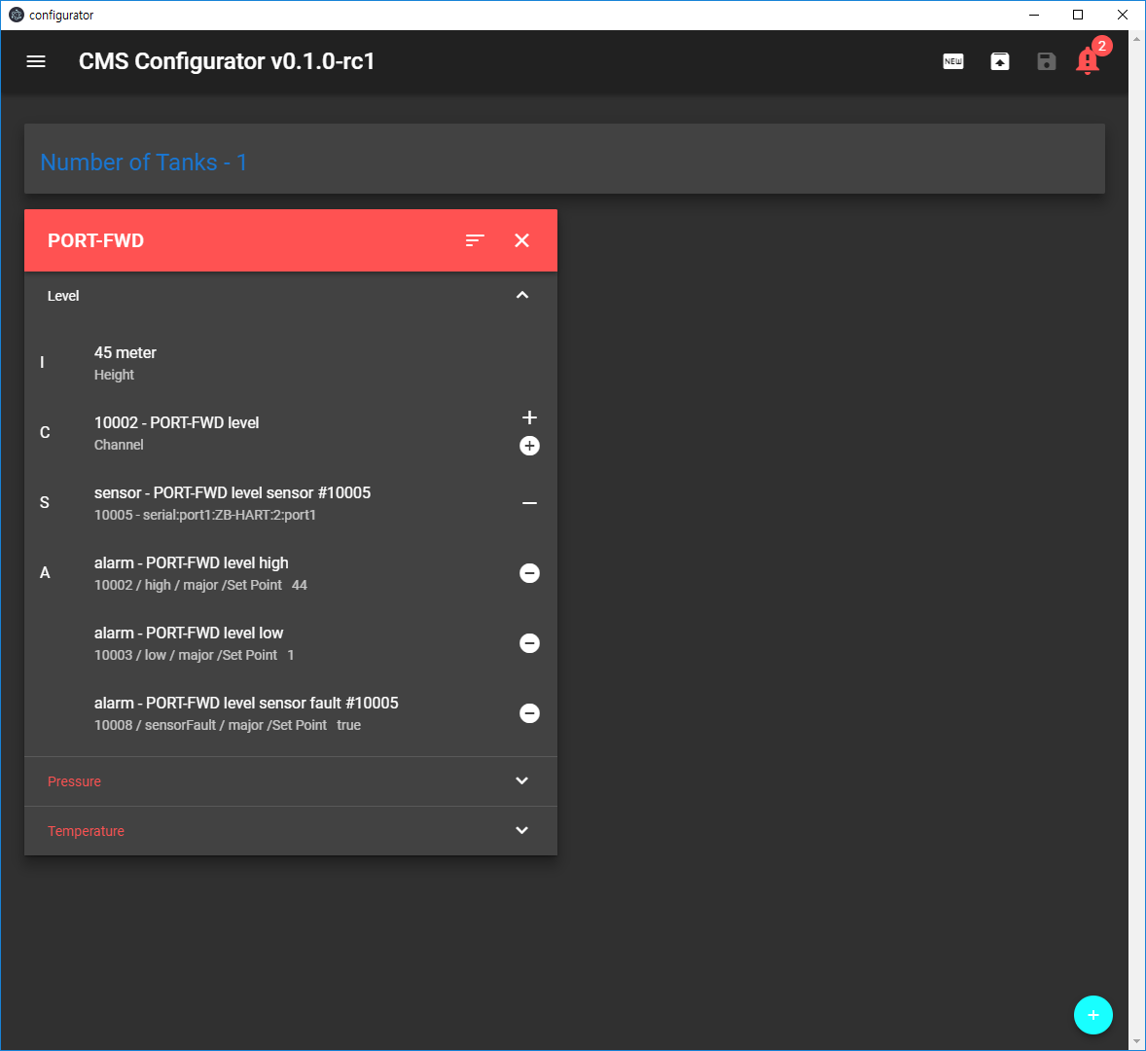

Level sensor list

‘-‘ = delete sensor

1. Tank configuration –level alarm configuration

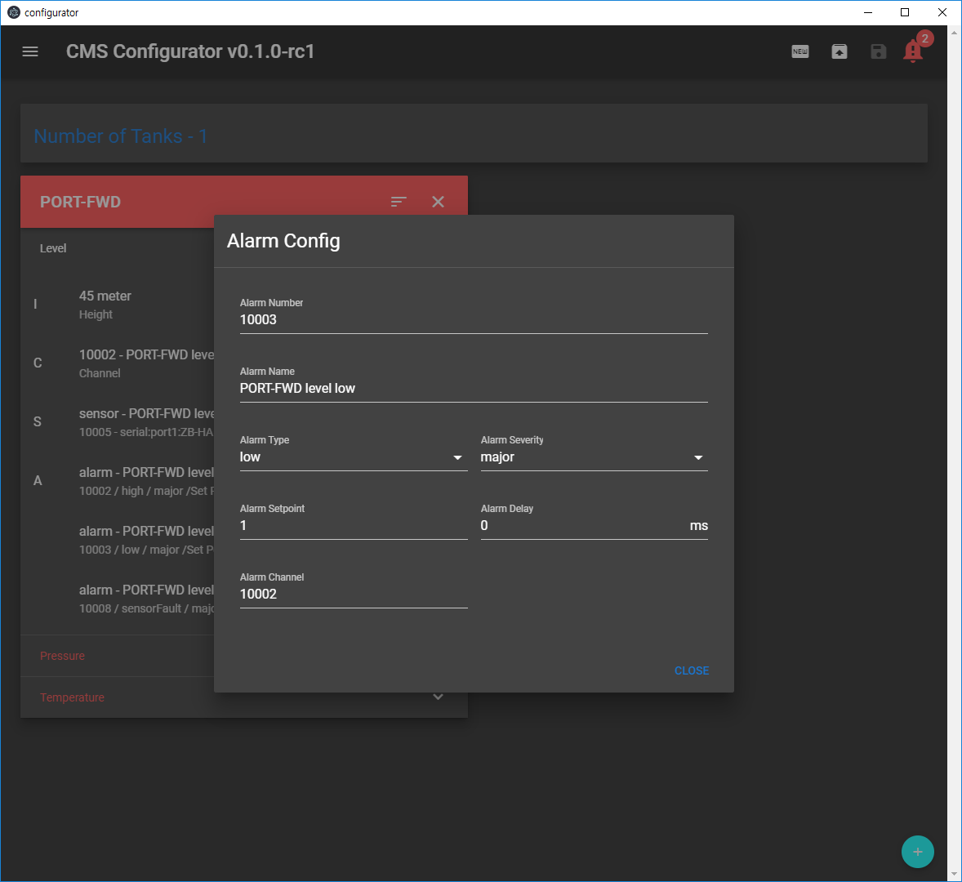

Alarm delay

Alarm set point

Alarm severity

High or low

Alarm name

1. Tank configuration – pressure

*BASICALLY the UI mechanism is same as level configuration*

1. Tank configuration – temperature

*BASICALLY the UI mechanism is same as level configuration*

Tank temperature decision mechanism (such as low, mid, high) will be determined later.

As of 0.1.0-rc1, this is just a template for future modification

1. Channel List

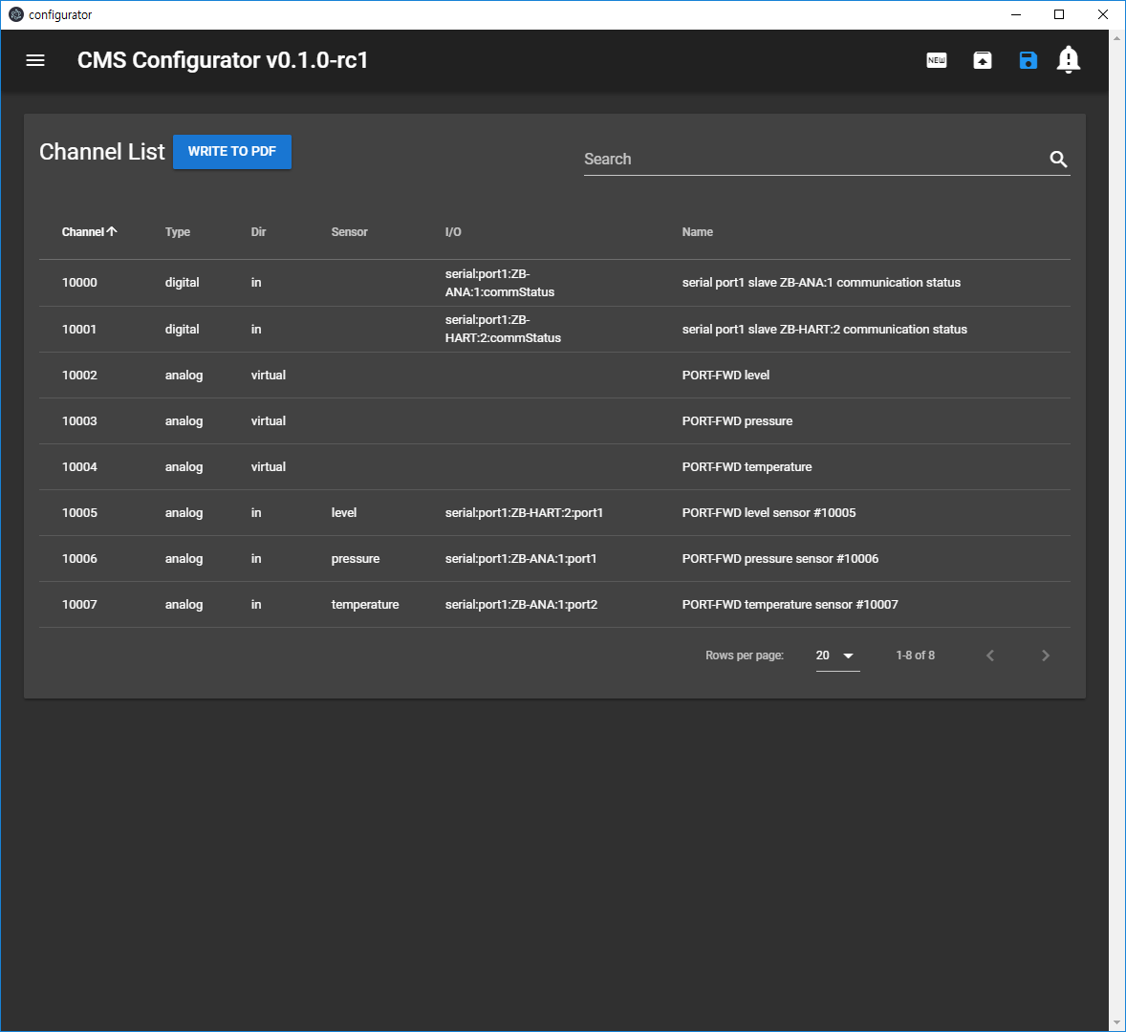

1. Alarm List

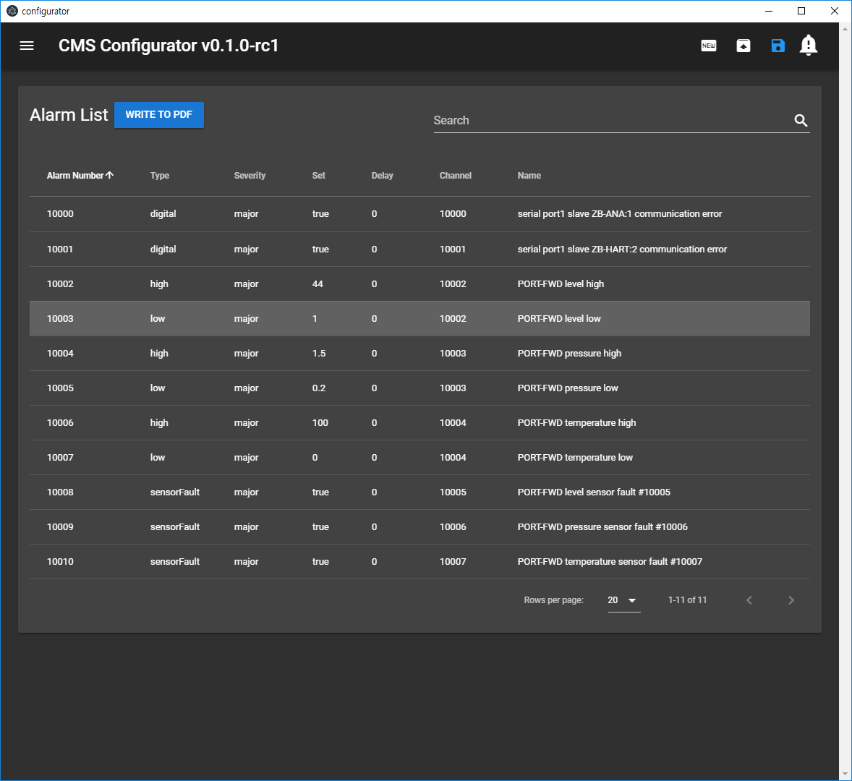

1. Config Error List

Basically,

Error = RED

No Error = White or Blue

**When there is any config error, saving project is disabled for safety reason. Fix the errors if there is any!!!**

